* -: In the last lecture, we saw how we can finally submit the form, extract the data we want to extract just so that you saw this too.
* That you just can access the value property on your form.
* Now, let's say we did extract all the data and now we want to reset the form.
* Well, turns out this is super simple.

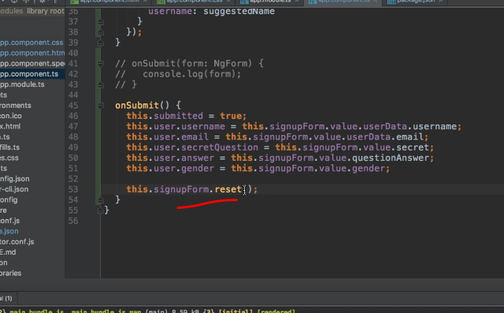

* On our form, sign up form in this case, which again is just fetched directly from our template with viewchild.
* On this form, we can call reset like this and this will reset the form.
* And what this means is it will not only empty all the inputs, you could do this with set value to as you learned.
* It will also reset the state like the valid detached and so on these properties.
* So now if I enter something here again like this and I hit submit, you see everything is empty.
* If we inspect it, you see that all the classes have been reset to pristine and valid and so on.
* So it's really like the page was loaded again.
* Very helpful to notice how to reset the forms.
* With that, you've got a great overview over how you can quickly create powerful forms with angular with the template driven approach.
* This approach might be well suited for the majority of your use cases.
* During the rest of the module though we're going to have a look at the other approach, the reactive approach which gives us even more control over our forms and which allows you to create more powerful forms, your own validators, and much more.
* So let's dive into this in the next lectures.